#Fómhar25
18.08.25

TG4 Unveils Autumn 2025 Schedule

Fresh Stories, Fearless Voices, and Unmissable Screen Moments

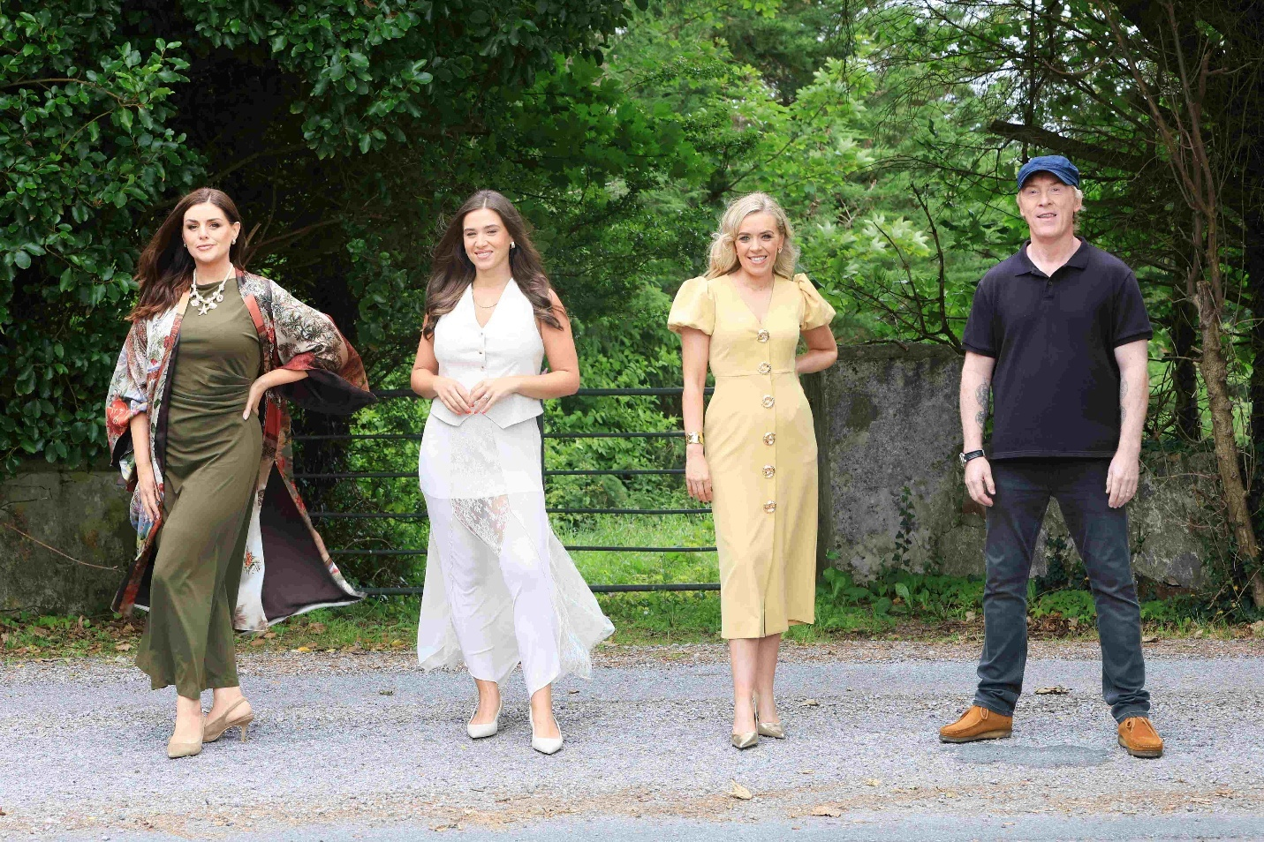
Síle Seoige, Síomha Ní Ruairc, Gemma Ní Chionnaith & Hector Ó hEochagáin- TG4 (credit Martina Regan)
TG4 Autumn Launch trailer: TG4 2025
Programme Images: Fómhar ar TG4
Cúla4 promo Cúla4 promo: Cúla4 2025
Press Pack and Images from the launch: TG4 2025
TG4 launched its Autumn 2025 schedule today at the Lighthouse Cinema in Smithfield, Dublin unveiling a season rich in new voices, original Irish language cinema, powerful documentaries, live sport, and imaginative children’s programming.
This year’s lineup showcases a diverse mix of compelling storytelling, from intimate portraits and cultural journeys to big-screen drama and unflinching social investigations.
It’s a season designed to reflect modern Ireland in all its complexity celebrating its creativity, examining its challenges, and exploring the places, people, and myths that shape it.
Director General of TG4, Deirdre Ní Choistín said: “TG4’s 2025 Autumn schedule reflects our strength as a trusted public service media brand, through continued commitment to Irish language creativity, stories that matter and to delivering real public value. In an English-dominated global media market, TG4 gives a unique perspective on Irish life as well as visibility and status to the Irish language.
We’re proud to be recognised for delivering exceptional public value. From our long-standing support of Ladies Football to Fleadh Cheoil na hÉireann and the success of our Cine4 film scheme with Fís Éireann and Coimisiún na Meán, to showcasing the best of traditional music Gradam Ceoil TG4 at Expo ‘25 in Osaka next month. Our recent drama series CRÁ; a partnership with BBC NI, Fís Éireann, NI Screen’s ILBF, now sold to 70 countries worldwide is proof of the global appetite for distinctive Irish storytelling.
Ten days ago, on the 8th August, the European Media Freedom Act came into effect in Europe. It is a landmark piece of legislation for TG4 and for public service media. EMFA provides that public service media should have adequate, sustainable, and predictable funding to fulfill their remit. Ireland has one of the lowest funded public service media as percentage of GDP according to EBU research. Ireland PSM funding is 0.08% of GDP compared to the EU average of 0.14%.
For TG4 to continue to grow and deliver for our audiences in Ireland and abroad; adequate, sustainable and predictable funding must align with European standards”.
Among the standout titles is Glúin Z, giving Gen Z Gaels a platform to share their perceptions and experiences; Síle Seoige – An Saol Mar Atá, where the presenter tackles bullying, parenting and anxiety with empathy and curiosity; Néara-Éagsúlacht: Dearcadh Difriúil, offers a deeply personal insight into neurodivergence and Ceartas Crua – Mná v An Dlí, is a two-part documentary series that examines the impact of 100 years of Ireland's judicial system on the country's women. Mná na Léinte Gorma reveals a complex legacy of power, identity, and the role of women in extremism - then and now. Beo Faoin bhFód delves into the extraordinary true story of Mick Meaney’s 1968 world record attempt to be buried alive.
Music and culture take centre stage in Ceol ón gCré, a lyrical exploration of rural Ireland’s traditions presented by Nell Ní Chróinín, and David Keenan – Focla ar Chanbhás, which follows the singer-songwriter over 500 days of creativity.

Nature and history intertwine in the striking Oileán Glas, Fásach Bán with Eoin Warner, capturing the Burren’s secret wild world; Aillte, a poetic exploration of Ireland’s dramatic cliffs; and Ag Lorg Hy-Brasil, ruminates on an ancient, mythical island off the Connemara coast and asks why it inspired Ireland's exhibit at the Architecture Biennale in Venice. Rounding out the line-up, Dath an Fhómhair captures the brilliance of later life through the stories of older adults who cycle, dance, sing, drum, and work with passion.
Glacaim Leat reflects on the legacy of marriage equality a decade after the Marriage Equality Act 2015 was implemented. Ar Son na Cúise brings a lighter touch as two lifelong friends, Joe Ó Domhnaill and Ray Mac Manuis travel the Gaeltacht in search of fun, and Ó Mhuir go Tír charts the evolution of travel between Ireland’s islands and the mainland. Hector OZ/NZ sees Ireland's intrepid traveller Hector Ó hEochagáin ‘Down Under’ for an epic adventure across Australia and New Zealand. Meanwhile, Téacs Taistil returns with its most action packed season yet, taking audiences on a fast-paced, culture rich journey around the globe featuring Louise Cantillon, Séaghan Ó Súilleabháin, Proinsias Ó Coinn and Laura Ní Aoidhne.
Audiences can also look forward to George Best i gCorcaigh, marking the 50th anniversary of the football legend’s time in the League of Ireland with his unexpected stint at Cork Celtic, captured through exclusive interviews and rare archive footage. Turning to the silver screen, Iománaíocht Hollywood explores how Ireland, Irish people, and Gaelic games have been portrayed in film for over a century.
Sport fans will also continue to enjoy TG4’s unrivaled live coverage, with GAA Beo, Rugbaí Beo, and Sacar na mBan Beo returning alongside documentary storytelling in Réalt na Mara FC and Ráth Chairn Peile na Mí. Current affairs remain sharp and relevant, with a new series of investigative current affairs Iniúchadh TG4, and news and analysis on Nuacht TG4, and 7 Lá.
On the cinematic front, TG4’s feature film initiative Cine4 in partnership with Fís Éireann and Coimisiún na Meán delivers another film this year. Báite is a haunting mystery set in 1975 rural Ireland after a body is found in a lake. Aontas a feature film from the Gealán scheme between TG4 and ILBF is a highly entertaining noir thriller of a botched robbery and the personal histories that shaped it. Short film Babaí Brain from a new Céim Eile scheme with Fís Éireann and NI Screen’s Irish Language Broadcast Fund, explores the obsession and isolation of a fertility journey in the wake of failed IVF.
With a blend of bold new commissions, ambitious Irish-language films, and trusted returning series, TG4’s Autumn 2025 season is a celebration of distinctive voices and original storytelling connecting audiences at home and abroad to the richness of Irish life today.
A wider look at TG4’s Brands
Cúla4, dedicated Irish language children’s channel, celebrates its second anniversary this September with a fresh lineup of original commissioned series for young audiences. The schedule mixes brand-new shows such as M’Ainm Mo Scéal, Dar le Daideo, Am Abú! and Anfa with much-loved international favourites dubbed in Irish, including Wonderblocks, Tiny Wonders and Curious George. Broadcasting daily from 6am to 8pm, Cúla4 offers a vibrant mix of entertainment and learning, as well as Nuacht Cúla4, a six minute news bulletin for children airing Tuesday to Friday at 1.30pm and 5.30pm.
Foghlaim TG4, the station’s online learning platform, remains the go-to destination for improving Irish and supporting teachers. Developed with educators, it offers comprehensive language learning resources.
This autumn sees the launch of ‘Tochailt’, a 20 part history series uncovering the lives of Ireland’s most famous historical figures, supported by learning materials from COGG. Also new is ‘Cúrsaí an Chontae’, an 8-part series exploring the stories, facts, and history of every Irish county, aimed at primary students.
For adult learners, ‘SNAS TV: Saol Ella’, providing Junior Cycle teachers with resources based on the acclaimed teen drama Saol Ella, set in the Gaeltacht.
MOLSCÉAL, continues to share stories from Gaeltacht areas and Irish-language communities across social media platforms.
BLOC, a social media hub for 18-35 year old Irish speakers, delivers fresh, engaging content while also encouraging it's followers to create content for the brand. BLOC is active on Instagram, YouTube, TikTok, Facebook and X.

ENDS
Additional press information, images, interview opportunities, and programme screeners are available on request.
Áine Lally, Communications Manager TG4 – aine.lally@tg4.ie
Linda Ní Ghríofa, Communications Editor TG4 – linda.ni.ghriofa@tg4.ie

